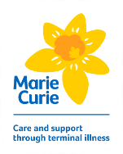  Please complete form below to refer a person to the Marie Curie ‘Talk About’ project.  Once the form is complete, please send it to: lat.mccompanionservice@nhs.net  Once received Marie Curie will contact the person, explain more about the service, and answer any questions, should they wish to proceed we will arrange an Advance Care Plan to be completed by a Marie Curie Companion.  If you have any questions or to make the referral over the phone contact us on 0800 3047412. | Marie Curie Talk About It  Referral Form | Date ………………

Name:

DOB:

NHS Number:

Address:

Home Telephone:

Mobile Telephone:

Email Address:

Has the patient consented to the referral? | Yes/No
NOK/Family/Support Network?
Including name & relationship

Any communication issues?

Does the patient have an up to date and fully completed TEP?

Any other relevant information?
e.g., is community palliative care involved? Is the GP aware of this referral?
Referrer Details:
Name, contact information and place of work

