Learning from Lives and Deaths People with a Learning Disability and Autistic People (LeDeR)
Information for families and circles of support
October 2021

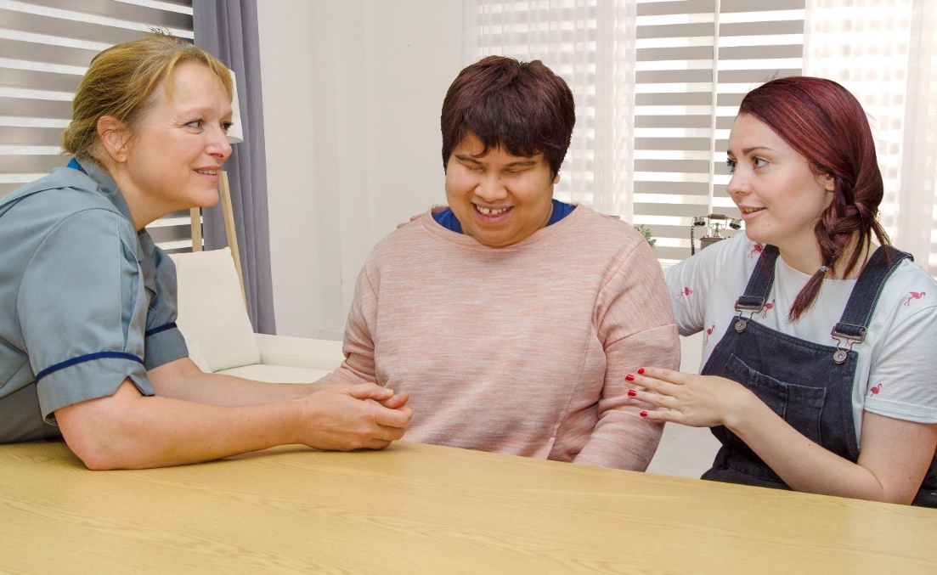

We know this may be a difficult time for you and we thank you for taking the time to read this leaflet. You can find out more information about LeDeR on the LeDeR website.

What is LeDeR?
LeDeR an improvement programme for services for people with a learning disability and autistic people.
Established in 2017 and funded by NHS England and NHS Improvement, it's the first of its kind. LeDeR works to:
- improve care for people with a learning disability and autistic people
- reduce health inequalities for people with a learning disability and autistic people
- prevent people with a learning disability and autistic people from early death
LeDeR reviews
A LeDeR review looks at key episodes of health and social care the person received that may have been relevant to their overall health outcomes. We look for areas of good practice and areas that need improvement. These examples of good practice are shared across the country.

A LeDeR review is not an investigation and it will only help to improve local, and in some cases national, services.

Why are families and circles of support so important to LeDeR?
Families often know the most about the care the person who died received. Their experience of services will influence high quality care and areas for improvement. This will also enhance our opportunity to learn; helping to improve services for other people.

Unless there is a specific reason not to, such as the person who died said they did not want family to be involved in their life, we will inform the family when we are undertaking a review and invite them to tell us about the person who died. We will also offer families:
- an opportunity to comment on the draft review
- a copy of the completed review

We understand that all families are different. We will:
- talk to families to help them decide how much involvement they want in the LeDeR review
- make sure our communication explains the purpose and limits of LeDeR reviews
- explain how families can raise questions or concerns, including those outside of the LeDeR process.

We will ensure that families are as comfortable as possible talking about their loved one and if requested, will arrange a further meeting to gather the information that is needed.

If a family member is not able to be identified, someone else who knew the person well is invited to contribute to the review. Reviewers may talk to other relatives, friends and other key people about the person’s life and the events leading up to the death of their relative or friend.

Who will do the LeDeR review?
A trained LeDeR reviewer will find out about the health and social care support that was provided to the person who has died. The LeDeR reviewer will be someone who has a health or social care background. They will find out about the person’s life and the key events that led up to their death. Reviewers identify good practice and areas for learning.
We will identify where changes could be made, and make sure actions are taken locally to improve services for other people with a learning disability and autistic people to reduce health inequalities and make sure that people are supported to live longer, healthier lives.

How a does a LeDeR review work?
Once we have been told the details of someone’s death we start the review process, which we aim to complete in six months. We know that some family members might not be ready to talk with us straight away and we will try to give the family time to be ready to talk to us but it is important that we learn as much as we can as soon as we can after the person has died.
A reviewer will complete an initial review which includes:
- speaking to the family member or someone close to the person who died. This allows us to build up a picture of their life and the type of person they were. This will help the reviewer understand more about the person. The reviewer might also speak to someone they lived with, their partner or a carer who they were close to.
- a detailed conversation with the GP or a review of the person’s GP records
- a conversation with at least one other person involved in the care of the person who died
After this, the reviewer uses their judgement to decide if a focused review needs to happen. A focused review will look in more detail at key episodes of health and social care the person received. A focused review will usually happen if:
- the reviewer finds areas of concern or things they think we can learn from
- the person is from a minority ethnic background. This is due to the significant under reporting and increased health inequalities in these communities
A family member can ask for a focused review to be carried out, but you should always be aware that a LeDeR review is not an investigation and is only there to help improve local services. If you have serious concerns about failures in NHS or social care services, the LeDeR process is not the best way to tackle these. You should contact the CQC.
If a family member asks for a focused review to be carried out, the reviewer will talk to them about the expected outcome of a LeDeR review. The reviewer will explain how to raise questions or concerns, including those outside of the LeDeR process.
The reviewer will send the completed anonymised review to the local governance group which includes local health and social care services with the areas of learning, good practice and concern. The group will decide on actions to take, who will take these actions and the help they need to reduce health inequalities and stop people dying too young.
Sometimes we cannot complete the review within 6 months because there might be other processes going on like a coroner’s inquest or another investigation. A LeDeR review waits until all these have happened first.

Does LeDeR review the deaths of children?
Everyone with a learning disability aged over four years is eligible for a LeDeR review.

The child death review process reviews the deaths of all children who are under the age of 18. This will be the primary review process for children with a learning disability and autistic children; the results are then shared with LeDeR.

LeDeR annual report
Nationally there is an analysis of all the LeDeR reviews that are done in a year and an annual report is produced. All the details of the people with a learning disability whose deaths have been reviewed are fully anonymised in the programme’s annual reports to protect confidentiality.

The full and easy-read versions of LeDeR’s annual reports are available to be downloaded online. Our latest Action from Learning report, describing improvements, is available to be downloaded here.

